

UNIVERSITI MALAYSIA TERENGGANU

FACULTY OF OCEAN ENGINEERING TECHNOLOGY & INFORMATICS

SEMESTER 2 2022/2023

CSM 3103

FRONT END PROGRAMMING

GROUP 13: LIVE WALLPAPER ANDROID PROJECT

PREPARED FOR:

DR. RABIEI BIN MAMAT

PREPARED BY:

ARUN MUGILAN A/L SARGUNAN (S63746)

FARIS ISKANDAR BIN ABD RAHMAN (S62371)

MOHAMAD HAZIM BIN MOHD SHAKRI (S61770)

[GARY LIM KHAI ZHE](mailto:s62079@ocean.umt.edu.my)(S62079)

**Introduction 3**

**Problem Statement 4**

**Objectives 5**

**Activity Design / Wireframe**

**Features of the Live Wallpaper Android Project: 6**

**Team Member 7**

# **Introduction**

In today’s digital era, personalization has become a key aspect of the user experience. One popular way to personalize mobile devices is through the use of live wallpapers. Live wallpapers are dynamic and interactive backgrounds that bring life to the home screen of Android devices. They provide users with visually captivating and engaging experiences, transforming their devices into a unique and immersive environment.

The Live Wallpaper Android Project aims to develop a cutting-edge application that allows users to customize their Android devices with a wide range of interactive and animated backgrounds. By leveraging the power of Android’s graphics capabilities, the project seeks to enhance the visual appeal of the homescreen, providing users with a fresh and dynamic interface.

The Live Wallpaper Android Project aims to create a feature-rich and visually appealing application that enhances the user experience on Android devices. By offering a wide range of interactive and customizable live wallpapers, the project seeks to provide users with a unique and immersive homescreen environment. Through performance optimization and integration with the Android operating system, this project strives to deliver a seamless and enjoyable live wallpaper experience for users, showcasing the potential of visual personalization in the realm of mobile devices.

# **Problem Statement**

The current state of live wallpapers on the Android platform presents several challenges that need to be addressed. Firstly, the existing live wallpaper applications lack a comprehensive library of high-quality and visually appealing animated backgrounds. Users often find themselves restricted to a limited set of options, which can quickly become monotonous and fail to reflect their diverse preferences and interests.

Secondly, the customization options provided by current live wallpaper applications are often limited and rigid. Users are unable to personalize the wallpapers according to their specific preferences, such as adjusting animation speed, changing color schemes, or incorporating interactive elements. This limitation hinders users from fully expressing their individuality and creating a truly unique and immersive experience on their Android devices.

Lastly, there is a lack of seamless integration between live wallpapers and other system features. Users often face difficulties in combining live wallpapers with their preferred launchers, widgets, and other interactive elements on their home screens. The disjointed experience can be frustrating and limits the usability and practicality of live wallpapers as a whole.

In summary, the problem at hand is to develop an innovative live wallpaper application for Android that addresses the shortcomings of current offerings. The solution should provide a vast and diverse collection of visually stunning and customizable animated backgrounds, empowering users to express their individuality. It should optimize performance and minimize resource consumption to ensure a smooth and seamless user experience. Additionally, the application should seamlessly integrate with other system features, allowing users to combine live wallpapers with their preferred launchers and widgets effortlessly. By addressing these challenges, the aim is to enhance the overall user experience and establish live wallpapers as a compelling and interactive feature of the Android ecosystem.

# **Objectives**

Live wallpaper app aims to fill this gap by providing users with an innovative and engaging way to personalize their devices. The app will feature a collection of stunning animations that can be adjusted according to the user’s preferences, such as speed, color and brightness. The app will also have a simple and intuitive interface that will allow users to easily browse, select and apply the live wallpapers. The app will be optimized for different devices and operating systems to ensure compatibility and smooth operation. The app will also have a low battery consumption mode that will reduce the impact of the live wallpapers on the device’s battery life.

Live Wallpaper will benefit users by creating an unique and immersive experience for users’ home screen, and allowing developers to generate revenue from the app through in-app purchases, advertisements and subscriptions.

**Activity Design / Wireframe**

At the bottom of figure 1, you have a button labeled "Settings." When users tap on this button, they will be taken to the settings screen for the live wallpaper. At the bottom of the settings screen, you have two buttons labeled "Save" and "Cancel." The "Save" button allows users to save their settings and apply them to the live wallpaper, while the "Cancel" button discards any changes and returns the user to the live wallpaper preview.

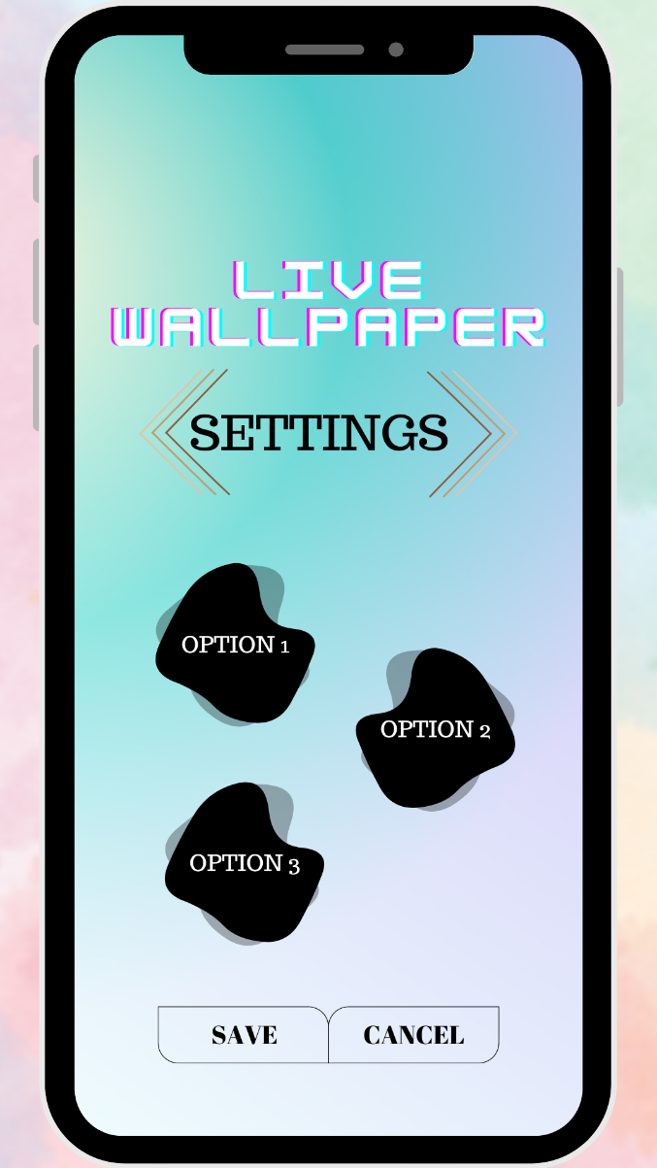Figure 1 Figure 2

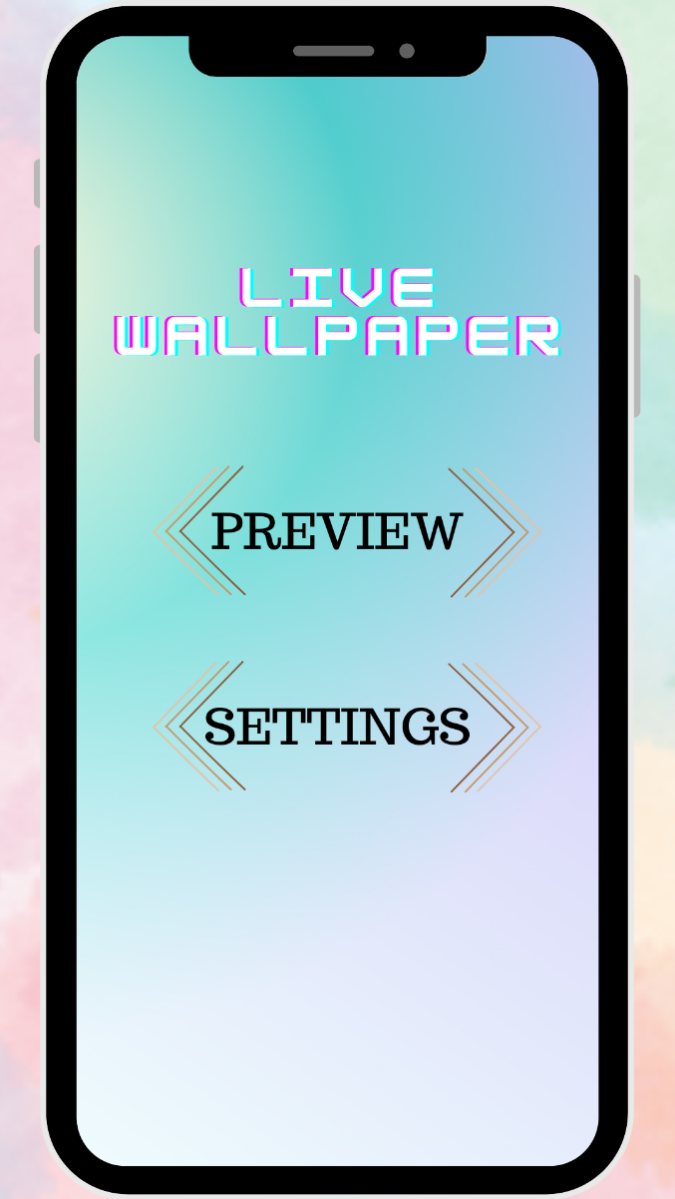

# **Features of the Live Wallpaper Android Project:**

1. Interactive Elements: The application will offer various interactive elements such as touch gestures, accelerometer-based animations, and gyroscope effects. Users can interact with the live wallpaper to trigger specific actions or animations, adding a sense of responsiveness and interactivity.

2. Customization Options: The project will provide users with an extensive collection of pre-designed live wallpapers to choose from. Additionally, users will have the ability to customize certain aspects of the live wallpapers, including color schemes, animation speed, particle effects, and more, enabling them to create a personalized visual experience.

3. Performance Optimization: The project will prioritize performance optimization to ensure that the live wallpapers do not negatively impact the device's battery life or overall performance. Efficient rendering techniques, resource management, and compatibility across a wide range of Android devices will be key considerations.

4. Wallpaper Repository: The application will include a repository where users can discover, download, and share live wallpapers created by other users or developers. This repository will foster a vibrant community and provide a platform for users to showcase their creativity.

5. Seamless Integration: The live wallpapers developed in this project will seamlessly integrate with the Android operating system, allowing users to set them as their device's wallpaper directly from the application. Users will also have the option to set different live wallpapers for the lock screen and home screen, further enhancing personalization.

# **Team Member**

|  |  |  |
| --- | --- | --- |
| NO | NAME | MATRIC NUMBER |
| 1 | ARUN MUGILAN A/L SARGUNAN | S62746 |
| 2 | MOHAMAD HAZIM BIN MOHD SHAKRI | S61770 |
| 3 | FARIS ISKANDAR BIN ABD RAHMAN | S62371 |
| 4 | GARY LIM KHAI ZHE | S62079 |